M/s. Elite Insurance – M/s. Two Trade Solutions and Sister Companies – Rice

Our reference: 260331 – 1v1
Applicant: M/s. Elite Insurance
Assured: M/s. Two Trade Solutions and Sister Companies – Sierraleone
Reinsurance Broker: M/s. Cope Insurance Brokers
09 June 2026


[Insert here client logo]
It’s about time you receive the quality of service and expertise your firm deserves.


Document Control Page
Inspected by: | Prepared & reviewed by: | Approved by:
Mohamed Bangura | Rana Rizk  Annie Abdel Massih | Petro Zaarour
Designation: | Designation: | Designation:
ULA Correspondent Surveyor | Claims Handler  Claims Director | Director
Signature (Approver)
This survey and its issued report are without prejudice to the rights and or defences of the parties concerned.
Date of approval
09 June 2026

Version history | Date of issue | Reason for Revision
1 | 09 June 2026 | Issued – Final unless underwriters require outstanding documents

The contents of this report are for the confidential information of the client.

Report Summary
At the request of Elite Insurance (the Applicant), ULA was requested to attend and investigate a marine cargo claim for M/s. Two Trade Solutions and Sister Companies (the Consignee/Assured) claiming on their policy, to quantify the extent of damage/loss and validate the claim on the subject policy when presented. Appendices A & B includes representative photographs and Table 1 is a detailed summary pertaining to this claim. The assignment of the policy between the parties was confirmed.
Table - Claim salient details
Assured’s Name | M/s. Two Trade Solutions and Sister Companies – Sierraleone as per policy
Broker/Agent Name | M/s. Elite Insurance
Insurer’s Name | M/s. Cope Insurance Brokers
Claimed Amount | USD 71,823.53- 3,931 bags / 173.925 MT claimed by the consignee as a total loss
In our opinion,
- The proximate cause of loss and damage is attributable to improper and negligent handling during discharge operations at Freetown Port, combined with stevedores’ misconduct and localized moisture exposure within the vessel’s cargo spaces.
Stevedore’s rough handling, including dragging, lifting, and dropping of bags, directly resulted in torn and ruptured bags and subsequent spillage leading to emptied units/bags.
The deliberate cutting of separation tarpaulins and associated misconduct and theft of rice bags, as reported on 07 April 2026, caused cargo mixing, shortage and aggravated overall handling losses.
Moisture exposure within Hold No. 5 resulted in localized caking and mold formation, although testing confirmed no seawater ingress, indicating the damage stemmed from inherent vice at origin rather than an insured peril.
- The adjusted claim USD 42,672.88 is fair & reasonable. Their claim excludes sorting and sue and labor charges;
- On the basis of the survey findings and supporting evidence presented, the proximate cause of the loss is considered to be improper and negligent handling during discharge operations at Freetown Port, including rough stevedoring practices, cargo spillage, tearing of bags, and shortages caused by theft.
- Localised moisture exposure within Hold No. 5 was observed; however, the limited number of bags found caked and mold-affected are most likely attributable to the inherent condition of the cargo at origin, rather than exposure to moisture during transit or discharge operations.
- As per the policy terms and exclusions, the losses consisting of torn bags, emptied bags, shortages, and handling-related damages are considered recoverable under Institute Cargo Clauses (A), including loading and unloading operations, shortage, and loss of weight extensions.
- However, the moldy/caked portion of the cargo is considered excluded from cover, as the damage was consistent with inherent vice and localized moisture exposure not resulting from an insured peril. Silver nitrate testing further confirmed the absence of seawater ingress or marine contamination.
- Accordingly, liability for the handling-related damages and shortages may reasonably attach to the Carrier and/or the appointed stevedores responsible for the discharge operations at Freetown Port, due to failure to exercise proper care in the handling, segregation, and protection of the cargo during discharge and delivery operations.
We confirm having sighted the originals of all documents customarily submitted in support of a claim of this nature.
Contents
1. Appointment of ULA by the Applicants – Elite Insurance 5
2. Shipment Routing 7
3. Surveyor’s Notes 7
3.1. Initial Notification and Inspection (29 March 2026) 7
3.2. Findings – during cargo discharge operation (29 March 2026 until 08 April 2026) 7
4. Notices of loss 8
4.1. Letters of Indemnity 8
4.2. Notice of Loss 8
4.3. Letters of Reserve / invitation for joint survey 9
5. Findings at the Consignee’s warehouses (28 April 2026) 9
6. Quantum of Loss 10
7. Certificates Supplied by The Consignee 10
8. Sales Contract 11
9. Proximate Cause of Loss/Damage 11
10. Warranties/Conditions Material to The Risk 11
11. Adequacy of Insured Value 12
12. Appointment of Assessors 12
13. Claim & Adjustment 12
14. Conclusions 13

Appointment of ULA by the Applicants – Elite Insurance
At the request of Elite Insurance (the Applicant), ULA was requested to attend and investigate a marine cargo claim for M/s. Two Trade Solutions and Sister Companies (the Consignee/Assured) claiming on their policy, to quantify the extent of damage/loss and validate the claim on the subject policy when presented. Appendices A & B includes representative photographs and Table 1 is a detailed summary pertaining to this claim. The assignment of the policy between the parties was confirmed.
Table 1 - Claim salient details
Assured’s Name | M/s. Two Trade Solutions and Sister Companies – Sierraleone
Broker/Agent Name | M/s. Elite Insurance – Ref No. 49/2026
Insurer’s Name | M/s. Cope Insurance Brokers
Policy Details | - Open Cover Policy No.: CPRLBN-2025-0593-QAT-MAR  - Period of Insurance 23 July 2025 till 22 July 2026  - Basis of Valuation: Invoice Value + 10%  - Total Sum Insured: USD 6,606,000.00 + 10% = USD 7,266,600.00  - Geographical Limits: From Worldwide to Sierra Leon.  - Deductible: For Bulk: 0.5% of shipment value each and every loss.  - Bulk Shipments Port to Assured’s warehouse (5 – 10 min from the port)  - Including Loading & Unloading  - Limit per shipment: USD 7,500,000.00 for Bulk Shipments  - Packing Mode: Rice – always in bags  - Institute Cargo Clauses “A” CL. 382 dated 01.01.2009  - Institute Replacement Clause CL. 372 dated 01.12.2008  - Packing Extension Clause as per Wording attached  - Sue and Labour Clause as per Wording attached  - Sorting Charges as per wording attached  - Repacking Costs as per Wording attached  - Goods Purchased on FOB, C&F, CIF or similar Terms Clause  - Including shortage & Loss of weight  - Including Heating, Sweating, Condensation and Spontaneous Combustion
Claim Relevant Exclusions & Warranties | Exclusions: Excluding Mysterious and/or Unexplained Disappearance  Warranties:  - Warranted Independent Satisfactory Pre-Shipment Loading, Stowage, Moisture Survey along with Loading and Discharge Bags Tally Survey at the Original Assured’s Expense, applicable to Bulk Shipments.  - Warranted that Quantity and Quality of Cargo loaded shall be Certified / Supervised by Qualified Third Party Independent Marine Surveyors with All Survey Fees at the Original Assured’s Expense applicable to bulk/breakbulk shipments.  - Warranted Third Party Independent Surveyors of International Repute to supervise the Loading and Unloading Operations with All Survey Fees at the Original Assured’s Expense, applicable to Bulk and/or Break-Bulk Shipments. (see enclosed certificates)  - Warranted Adequate Cleansing of the Vessel Chambers for carriage of such Goods applicable to Bulk and/or Break-Bulk Shipments. (see enclosed certificates)  - Warranted Third Party Independent Surveyors of International Repute to supervise the Loading Operations with All Survey Fees at the Original Assurer's Expense, applicable to Bulk and/or Break-Bulk Shipments.  - Warranted Vessels must be IACS Classed with Class maintained at all times during sailing.  - Warranted Vessels entered into a reputable P&I Group / Club / Association.  - Warranted Shipped under a clean Original Bill of Lading and/or Original Air Waybill and/or Original Packing List and/or Original Commercial Invoice and/or Original Shipping Manifest.  Law and Jurisdiction: Governed by and construed in accordance with the Law of England and Wales and each party to submit exclusive Jurisdiction to the courts of England and Wales.
Terms of Sale | CFR Freetown Incoterms – as per enclosed Invoices issued on 12 February 2026 by M/s OMM Agroexim Private Limited.  CFR Sierra Leone - as per Invoices issued on 12 February 2026 by M/s Sarala Foods PVT LTD.
Cargo Ownership | Sales Contract: No. SFPL/TTSL/JAN-08/25-26 issued by M/s. Sarala Foods PVT. LTD. On 28 January 2026.  Sales Contract: No. OAEPL/TTSL/JAN-06/25-26 issued by M/s. OMM Agro Exim PVT. LTD. On 28 January 2026.  Evidenced by proof of payment (transfer copies enclosed)
Shipper’s / Seller’s Name | M/s. Sarala Foods PVT. LTD., East Godavari District, Andhra Pradesh, India  M/s. OMM Agro Exim PVT. Ltd., East Godavari District, Andhra Pradesh, India
Buyer’s Name | M/s. Two Trade Solution SL LTD, Freetown Town, Sierra Leon
Bills of Lading (Clean – No clausing) | All BLs signed for and on behalf of master of M.V. Hoang ANH 36, Capt. Le Dinh Hung, For Lotus Marine Logistics LLP as agent dated 24 February 2026.  Notify Party on all BLs: M/s. Two Trade Solution SL LTD, Freetown, Sierra Leone.  Total Quantities: Net Weight 16,000 MT – 360,000 Bags
No.: 01F / Shipper’s Name: M/s. Sarala Foods PVT LTD., Kakinada, India.
Commodities: Bags Marks: Fambul - 130,000 bags of Indian Long Grain Parboiled Rice 5% Broken. Packing in 50 Kg of new single Bopp bags. Total Net Weight: 6,500.000 MTS
No.: 02F / Shipper’s Name: M/s. Sarala Foods PVT LTD., Kakinada, India.
Commodities: Bags Marks: Gold Coin - 10,000 bags of Indian Medium Grain Parboiled Rice 5% Broken. Packing in 50 Kg of new PP bags. Total Net Weight: 500.000 MTS
No.: 03F / Shipper’s Name: M/s. Sarala Foods PVT LTD., Kakinada, India.
Commodities: Bags Marks: Pearl - 20,000 bags of Indian Long Grain Parboiled Rice 5% Broken. Packing in 50 Kg of new single Bopp bags. Total Net Weight: 1,000 MTS
No.: 04F / Shipper’s Name: M/s. OMM Agroexim Private Limited., Kakinada, India.
Commodities: Bags Marks: Gold Coin - 10,000 bags of Indian Medium Grain Parboiled Rice 5% Broken. Packing in 50 Kg of new PP bags. Total Net Weight: 500.000 MTS
No.: 05F / Shipper’s Name: M/s. OMM Agroexim Private Limited., Kakinada, India.
Commodities: Bags Marks: Master
- 60,000 bags of Indian Long Grain Parboiled Rice 5% Broken IR 64 Sortexed. Packing in 50 Kg of new single Bopp bags. Total Net Weight: 3,000.000 MTS
- 40,000 bags of Indian Long Grain Parboiled Rice 5% Broken IR 64 Sortexed. Packing in 25 Kg of new single Bopp bags. Total Net Weight: 1,000.000 MTS
No.: 06F / Shipper’s Name: M/s. OMM Agroexim Private Limited., Kakinada, India.
Commodities:
Bags Marks: Fambul
- 50,000 bags of Indian Long Grain Parboiled Rice 5% Broken IR 64 Sortexed. Packing in 50 Kg of new single Bopp bags. Total Net Weight: 2,500.000 MTS
- 40,000 bags of Indian Long Grain Parboiled Rice 5% Broken IR 64 Sortexed. Packing in 25 Kg of new single Bopp bags. Total Net Weight: 1,000.000 MTS
Note: The Charterparty agreement was not supplied only the Fixture note was made available.
Port of Loading | Kakinada, India
Port of Discharge | Freetown, Sierra Leone
Vessel | MV “HOANG ANH 36” (IMO Number: 9422495) Bulk carrier – Flag: Panama; Year built: 2010; Call Sign: 3E8921; Class: NK (IACS classed); P&I Club: H.A.S Container Shipping Limited Company (West of England)
Date Of Cargo Loading | Date of Cargo loading into the vessel: 17 to 24 February 2026. The vessel sailed on 25 February 2026 from the port of loading
Supervising The Loading Body | M/s. Virtue Inspection Services PVT. LTD (loading procedures, including fumigation, among others: Samples were drawn according to GAFTA rules, sealed, and tested in the laboratory for moisture, brokens, damage, foreign matter, grain length, and milling degree). Cargo loaded inside holds nos. 1, 2, 3, 4 & 5 as per the stowage plan (Copy enclosed)
Unloading Commenced | On 29 March 2026 at port of discharge
Date And Location of Survey | ULA was appointed on 29 March 2026 to inspect the bulk cargo after damage in the form of torn bags was observed. On the same day, ULA correspondent surveyor attended the port of discharge and subsequently monitored the discharging process from 29 March until 08 April 2026. Afterwards, following cargo segregation, a joint survey was conducted at the consignee’s warehouse on 28 April 2026, completing the inspection cycle and documenting the extent of the damage and segregation results.
Attending Survey | Mr. Mohamed Bangura – ULA correspondent Surveyor;  Mr. Aluslne Bangura – Carrier representative;  Mr. Mohamed Kamara– Consignee’s representative;  Chief officer of MV “HOANG ANH 36” during unloading only at final discharge port;
Packaging | 50 Kg bags in BOPP and PP bags  25 kg bags in BOPP Bags
Claimed Amount / Indemnity | USD 71,823.53 - 3,931 bags / 173.925 MT claimed by consignee as total loss

Shipment Routing
The subject consignment was shipped from Kakinada port onboard the vessel MV “HOANG ANH 36” under clean onboard Bills of Lading Nos. 01F, 02F, 03F, 04F, 05F, and 06F (copies enclosed). The loading operations were carried out between 17 February 2026 and 24 February 2026 under the supervision of M/s. Virtue Inspection Services PVT. LTD., whose Inspection Certificate confirmed that the cargo was loaded in sound condition.
Following completion of loading, the vessel sailed from the port of Kakinada on 25 February 2026 and subsequently arrived and anchored at the discharge port of Freetown on 28 March 2026. Upon completion of the discharge operations, the cargo was transported and delivered to the Consignee’s premises within Sierra Leone.

Surveyor’s Notes

Initial Notification and Inspection (29 March 2026)
On 29 March 2026, ULA was formally notified by the Applicants regarding the reported cargo damage onboard MV “HOANG ANH 36” upon arrival at the final destination port. On the same date, ULA’s appointed correspondent surveyor attended onboard the vessel during the discharge operations in order to inspect the condition of the cargo and monitor the entire remaining unloading process.

Findings – during cargo discharge operation (29 March 2026 until 08 April 2026)
- Commencement & Completion: ULA monitoring discharge operations commenced on 29 March 2026 at Freetown Port, Sierra Leone, and were completed on 08 April 2026.
- Survey Attendance: ULA attended the full discharging process onboard the carrying vessel. Inspections were carried out in conjunction with the cargo discharge operations.
- Total Quantity Discharged: A total of 356,069 bags were discharged from the vessel.
- Packaging Details: The cargo was packed in two categories 50 Kg bags and 25 Kg bags of different brand marks.
- Findings:
- The torn bags were primarily the result of stevedores handling during discharge operations, where rough lifting, dragging, and dropping caused ruptures.
- Additional losses occurred due to transit friction and contact with sharp surfaces while being moved from quay to warehouse.
- Sections of the kraft paper within the vessel’s cargo spaces were found wet.
- 127 bags exhibited extensive and complete mold growth found in hold No. 5 during the last days of discharging, consistent with prolonged exposure to moisture, most probably rising from inherent vice at origin.
- A silver nitrate test was conducted on the wet and affected areas; no change in color was observed, indicating no evidence of chloride contamination or seawater ingress.
- A total of 4,738 torn bags and 93 emptied bags were recorded from the 50 kg category, together with 127 mouldy/caked bags.
- From the 25 kg category, 805 torn bags and 165 emptied bags were identified, with no moldy/caked bags reported.
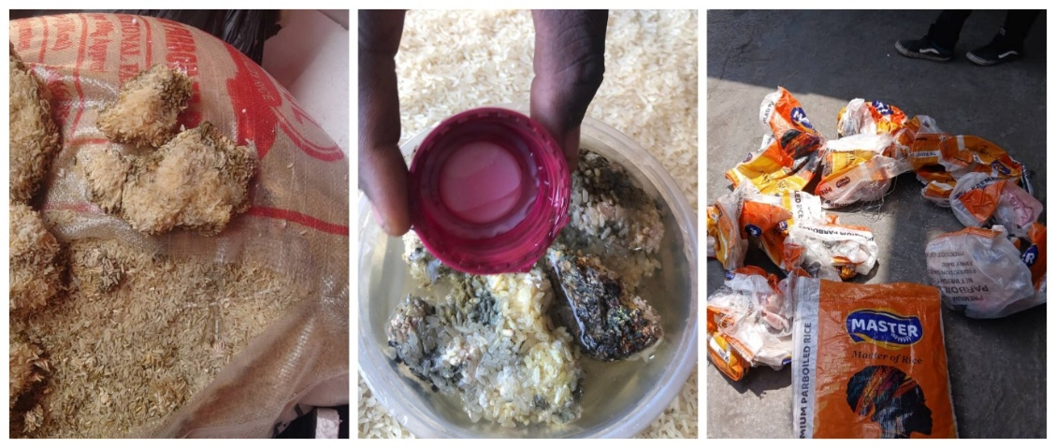
Figure 1 - Photographs of torn bags, mold and silver nitrate testing
It should be noted that, as per the Delivery Orders issued by Alsalam Marine Agencies (SL) Limited on 26 March 2026 and the Mates’ Receipts issued at origin (copies enclosed), the full manifested cargo quantity of 16,000 MT was recorded with no shortage noted or remarks.
However, during cargo discharge from vessel, the Statements of Facts issued by Alsalam Marine Agencies (SL) Limited recorded a short-landed quantity of 58.85 MT, equivalent to 887 bags of 50 kg and 580 bags of 25 kg.

Notices of loss

Letters of Indemnity
In the context of enclosed Letters of Indemnity, M/s. Indo Sino Trade Pte Ltd is the chartering and trading company that issued indemnities to H.A.S Container Shipping Ltd, requesting delivery of rice cargoes in Sierra Leone without presentation of original Bills of Lading, while guaranteeing to indemnify the shipowners against claims. This shows ISTL’s role as the cargo owner/charterer.

Notice of Loss
On 07 April 2026, the Operations Department in M/s Indo Sino Trade PTE LTD. formally notified all concerned parties by email of continuing misconduct and theft by stevedores during discharge operations at Freetown, Sierra Leone. The correspondence documented deliberate cutting of separation tarpaulins between cargo designated for Freetown and Dakar, resulting in extensive damage, numerous torn bags, and serious mixing of cargo (Copy enclosed).

Letters of Reserve / invitation for joint survey
Following the reported above and the observed damages and shortages recorded during discharge operations, the Consignee/Notifying Party M/s. Two Trade Solutions, issued three separate Letters of Reserve dated 04 April 2026 to the Master, Charterers, Owners, and Stevedores of MV “HOANG ANH 36”, formally notifying them of the discrepancies in quantity and condition of the cargo and inviting their attendance at a joint survey at the consignee’s warehouse for final segregation, and damage count.
Subsequently, after full delivery of the cargo to the Consignee’s premises, M/s. Two trade Solutions sent a Notice of Claim via mail email, dated 14 April 2026, confirming the damages and shortages sustained by the cargo and inviting the Carrier to attend a joint survey at the warehouse, followed by a formal invitation letter served on 24 April 2026 (Copies enclosed).

Findings at the Consignee’s warehouses (28 April 2026)
During the course of unloading and subsequent examination, the cargo of Indian Parboiled Rice 5% Broken was found to be in mixed condition. A joint survey was conducted at the Consignee’s warehouse in Freetown, Sierra Leone, in the presence of the parties listed in Table 1, during which the following findings were recorded:
- Out of the total manifested quantity of 360,000 bags, a substantial portion was received in sound condition; however, part of the cargo sustained damages in the form of torn bags, moldy/caked bags, shortages, and emptied bags.
- The survey established the presence of 4,738 torn bags, equivalent to 236.90 MT.
- In addition, 127 bags were found mouldy/caked, equivalent to 6.35 MT.
- Shortages / Stolen amounting to 1,094 bags, equivalent to 54.70 MT, were also recorded (Loading report, stowage plan, mates receipts … all prove that cargo was loaded in accordance to quantities declared - no shortage).
- Furthermore, 93 bags were found completely emptied, equivalent to 4.65 MT.
- Following standardization and reconditioning operations, part of the torn cargo was reconditioned and repacked; nevertheless, the net damage loss for the 50 kg units was assessed at 1,781 bags, equivalent to 89.05 MT).
- When combined with shortages and emptied bags, the total loss for 50kg units amounted 3,026 bags equivalent to 151.30 MT.
- The 25kg units reflected an additional 905 bags (22.63 MT).

Accordingly, the overall total loss observed across all cargo marks and bag sizes was assessed at 3,931 bags, equivalent to 173.925 MT, as duly recorded in the survey findings.
These findings were in addition to the damages and shortages previously observed and recorded during discharge operations at the port and were subsequently verified and confirmed during the comprehensive joint inspection conducted at the Consignee’s warehouse premises, as duly acknowledged and signed by the attending parties in the enclosed Statement of Facts.

Quantum of Loss
Following complete segregation, circa half of the torn bags had been reconditioned into empty bags. Based on the combined inspections conducted at the port of discharge between 29 March and 08 April 2026 and the joint inspection carried out at the Consignee’s warehouses on 28 April 2026, the total affected cargo was comprehensively assessed. The consolidated findings are presented in Table 2 below.
Table 2 – Extent of damage/loss
Cargo Description | Marks | Manifested In bags | Total Torn | Total Moldy | Shortage | Emptied
Indian Long Grain Parboiled Rice 5% Broken | FAMBUL  (50kg/bag) | 180,000 | 1,043 | 43 | 981 | 18
 | PEARL  (50kg/bag) | 20,000 | 305 | 15 | - | 21
Indian Long Grain Parboiled Rice 5% Broken IR 64 Sortexed | MASTER  (50kg/bag) | 60,000 | 339 | - | 34 | 27
 | MASTER  (25kg/bag) | 40,000 | 225 | - | 353 | 105
 | FAMBUL  (25kg/bag) | 40,000 | 100 | - | 62 | 60
Indian Medium Grain Parboiled Rice 5% Broken | GOLD COIN  (50kg/bag) | 20,000 | 94 | - | 79 | 27
Total |  | 360,000 | 2,106 | 58 | 1,509 | 258

Certificates Supplied by The Consignee
The Consignee supplied all available documents and certificates in support of their claim to evidence that the cargo was in sound condition prior to loading onboard. These were primarily produced by issued by Virtue Inspection Services Pvt. Ltd., whom the Seller had employed as a professional third party.
This included the following submissions (copies enclosed):
- Phytosanitary Certificates issued by the Government of India, Ministry of Agriculture & Farmers Welfare, Directorate of Plant Protection, Quarantine & Storage (PPQS), Quarantine Station Kakinada; dated 26 February 2026.
- Certificates of Origin issued by the Cocanada Chamber of Commerce, Kakinada, East Godavari, Andhra Pradesh, India, dated 05 March 2026;
- Fumigation Certificates for the 6 shipments issued on 02 March 2026 fumigation date 25 February 2026, issued by Pest Mortem (India) Private Limited; Certificate Nos.: PMI/KKD/ALP/1232/25-26, 1233/25-26, 1234/25-26, 1240/25-26, and 1242/25-26 (1/6 certificates missing – pending receipt)
- Certificates of Weight and Quality dated 05 March 2026 issued by Virtue Inspection Services Pvt. Ltd. at Kakinada, India, covering shipments loaded onboard MV HOANG ANH 36; Certificate Nos: VIS-CRT-25-26-382-D, VIS-CRT-25-26-382-E, VIS-CRT-25-26-382-F, VIS-CRT-25-26-383-E, VIS-CRT-25-26-383-F & VIS-CRT-25-26-383-G.
- Cargo Manifest mentioning loaded quantities which are in accordance with the shipped quantities.
The supporting prescribed information suggested that the cargo was of:
- Adequate quality as per Virtue Inspection Services Pvt. Ltd;
- Adequately prepared by Virtue Inspection Services Pvt. Ltd (fumigation etc.)
- Loaded clean onboard.
- Quantity The quantities stated in the loading reports, cargo manifest, and delivery order to MV “HOANG ANH 36” are consistent and match those indicated in the above-mentioned certificates.

Sales Contract
- Sales Contract ref: SFPL/TTSL/JAN-08/25-26 between Sarala Foods and M/s. Two Trade Solution SL Ltd, issued on 28 January 2026, covering shipment of parboiled rice to be shipped from India to Sierra Leon, evidenced by proof of payment (transfer copies enclosed).
- Sales Contract ref: OAEPL/TTSL/JAN-06/25-26 between M/s. OMM Agro Exim PVT and M/s. Two Trade Solution SL Ltd, issued on 28 January 2026, covering shipment of parboiled rice to be shipped from India to Sierra Leon, evidenced by proof of payment (transfer copies enclosed)

Proximate Cause of Loss/Damage
The proximate cause of loss and damage is attributable to improper and negligent handling during discharge operations at Freetown Port, combined with stevedores’ misconduct and localized moisture exposure within the vessel’s cargo spaces.
- Stevedores’ rough handling, including dragging, lifting, and dropping of bags, directly resulted in torn and ruptured bags and subsequent spillage leading to emptied units/bags.
- The deliberate cutting of separation tarpaulins and associated misconduct and theft of rice bags, as reported on 07 April 2026, caused cargo mixing, shortage and aggravated overall handling losses.
- Moisture exposure within Hold No. 5 resulted in localized caking and mold formation, although testing confirmed no seawater ingress, indicating the damage stemmed from inherent vice at origin rather than an insured peril.

Warranties/Conditions Material to The Risk
The following relevant Basis of Cover were examined as part of validating the subject claim:
- Institute Cargo Clauses “A” CL. 382 dated 01.01.2009
- Institute Replacement Clause CL. 372 dated 01.12.2008
- Packing Extension Clause as per Wording attached
- Sue and Labour Clause as per Wording attached
- Sorting Charges as per wording attached
- Repacking Costs as per Wording attached
- Goods Purchased on FOB, C&F, CIF or similar Terms Clause
- Including shortage & Loss of weight
- Including Heating, Sweating, Condensation and Spontaneous Combustion

Warranties:
- Warranted Independent Satisfactory Pre-Shipment Loading, Stowage, Moisture Survey along with Loading and Discharge Bags Tally Survey at the Original Assured’s Expense, applicable to Bulk Shipments. (Copies enclosed)
- Warranted that Quantity and Quality of Cargo loaded shall be Certified / Supervised by Qualified Third Party Independent Marine Surveyors with All Survey Fees at the Original Assured’s Expense applicable to bulk/breakbulk shipments. (See enclosed certificates)
- Warranted Third Party Independent Surveyors of International Repute to supervise the Loading and Unloading Operations with All Survey Fees at the Original Assured’s Expense applicable to Bulk and/or Break-Bulk Shipments. (see enclosed certificates)
- Warranted Adequate Cleansing of the Vessel Chambers for carriage of such Goods applicable to Bulk and/or Break-Bulk Shipments. (see enclosed certificates)

- Warranted Vessels must be IACS Classed with Class maintained at all times during sailing.
- Warranted Vessels entered into a reputable P&I Group / Club / Association.
- Warranted Shipped under a clean Original Bill of Lading and/or Original Air Waybill and/or Original Packing List and/or Original Commercial Invoice and/or Original Shipping Manifest. (Copies enclosed)
Exclusions:
- Excluding Mysterious and/or Unexplained Disappearance (Not applicable to this claim)
On review of the policy material conditions, we are of the view that none of these had been breached.

Adequacy of Insured Value
The Insured Value of the subject consignment is equivalent to the Invoice Value + 10% as per the specific schedule, indicating that coverage is appropriate, suggesting no evidence of cargo underinsurance. In addition, it is below the limits per Shipment: USD 7,500,000.00 for bulk shipments.

Appointment of Assessors
To date, it is understood that the Assured had not appointed a loss assessor to act on their behalf.

Claim & Adjustment
On receipt of Commercial Invoices Nos. OE/EXP/248/25‑26, OE/EXP/249/25‑26, OE/EXP/250/25‑26, OE/EXP/251/25‑26 and OE/EXP/ 252 /25-26 issued by the Seller M/s OMM Agroexim Private Limited dated 12 February 2026, together with Invoices Nos. SF/EXP/300/25‑26, SF/EXP/301/25‑26, and SF/EXP/302/25‑26 issued by M/s Sarala Foods Pvt. Ltd. also dated 12 February 2026, the Assured presented a claim for losses sustained during discharge operations at Freetown. The adjusted claim is reproduced in Table 3 below. ULA was able to confirm that the below “Shortage” cargo quantity had been shipped onboard at origin and later lost by theft at the port of discharge by the stevedore.

Table 3 – Claim and adjustment
Mark | No. of Bags  Damaged | Quantity Lost/ MT | Value in USD/MT | Claimed Amount USD | Cover Advice
Fambul – 50 Kg | 2,085 | 104.25 | 413.00 | 43,055.25 | Covered (Rough handling/ shortage – torn - emptied)
Master - 50 Kg | 400 | 20.00 | 413.00 | 8,260.00 | Covered (Rough handling/ shortage – torn - emptied)
Pearl - 50 Kg | 341 | 17.05 | 413.00 | 7,041.65 | Covered (Rough handling/ shortage – torn - emptied)
Gold coin - 50 Kg | 200 | 10.00 | 403.00 | 4,030.00 | Covered (Rough handling/ shortage – torn - emptied)
Fambul / Pearl - 50 Kg | 58 | 2.900 | 413.00 | 1,197.70 | Not covered – mouldy from origin – inherent vice
Fambul – 25 kg | 455 | 11.38 | 417.00 | 4,745.38 | Covered (Rough handling/ shortage – torn - emptied)
Master – 25 kg | 450 | 11.25 | 417.00 | 4,691.25 | Covered (Rough handling/ shortage – torn - emptied)
Claimed amount------------------------------------------------------------------------------------------------------------ USD 71,823.53
Uplift 10% as per the policy (USD 7,182.35) ------------------------------------------------------------------------- USD 79,005.88
Less Deductible (0.5% of shipment value each and every loss) USD 36,333.00 ---------------------------- USD 42,672.88
Say U.S. Dollars Forty-Two Thousand Six Hundred Seventy-Two & 88/100 Only.

Conclusions
In our opinion,
- The adjusted claim of USD 42,672.88 is fair & reasonable. Their claim excludes sorting and sue and labor charges;
- On the basis of the survey findings and supporting evidence presented, the proximate cause of the loss is considered to be improper and negligent handling during discharge operations at Freetown Port, including rough stevedoring practices, cargo spillage, tearing of bags, and shortages caused by theft.
- Localized moisture exposure within Hold No. 5 was observed; however, the limited number of bags found caked and mold-affected are most likely attributable to the inherent condition of the cargo at origin, rather than exposure to moisture during transit or discharge operations.
- As per the policy terms, the losses consisting of torn bags, emptied bags, shortages, and handling-related damage are considered recoverable under Clause 1 of Institute Cargo Clauses (A), including loading and unloading operations, shortage, and loss of weight extensions.
However, the moldy/caked portion of the cargo is considered excluded from cover, as the damage was consistent with inherent vice and localized moisture exposure not resulting from an insured peril. Silver nitrate testing further confirmed the absence of seawater ingress or marine contamination.
- Accordingly, liability for the handling-related damages and shortages reasonably attaches to the Carrier and the stevedores as their servants responsible for the discharge operations at Freetown Port, due to failure to exercise proper care in the handling, segregation, and protection of the cargo during discharge and delivery operations. Additional details on the merits of the recovery against the appropriate party are to be further scrutinised on receipt of the charterparty agreement.
We confirm having sighted the originals of all documents customarily submitted in support of a claim of this nature and remain at Insurers disposal for further instructions.
End of report.

Claim supporting documents
ENCLOSED DOCUMENTS MADE AVAILABLE TO DATE:
- Open Cover Policy No CPRLBN-2025-0593-QAT-MAR
- Insurance policy Schedule
- Bills of Lading
- Invoices
- Fixture Note
- Addendum To Charter
- Contract of sale Sarala
- Contract of Sale OMM
- Delivery Order for MV HOANG ANH 36
- LOP Charterer
- LOP Master
- LOP Stevedores
- MV Hoang ANH 36 -Vessel Documents
- Joint survey Invitation to Carrier
- MV Hoang ANH 36 – other Surveyor’s Reports
- Statement of Facts
- Reconditioning 25 KG
- Reconditioning 50 KG
- Final Tally Signed
- Consignee Claim
- Daily Tally Sheets
- Final Tally Sheet - Signed
- SOF
- Hold’s Ventilation Records
- Logbook
- Maintenance Records
- Mate’s Receipts
- Proof of Payments (Sarala & OMM)
- Certificates of Origin
- Fumigation Certificates
- Sanitary Health Certificates
- Loading Reports
- Letters of Indemnity
- Notification of Damages
- Invitation to carrier for a joint survey
CLAIM OUTSTANDING DOCUMENTS – NOT MADE AVILABLE:
- Charterparty Agreement
- Stevedore damage report (if any was issued)
- Sealing Report
- Fumigation certificate of BL 05F

            - Survey representative photographs during discharge (Additional available on request)
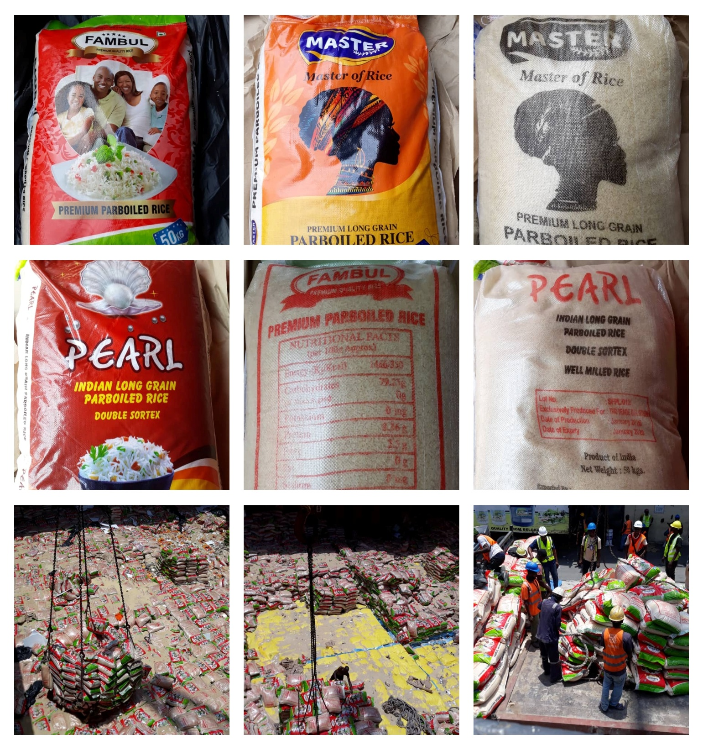

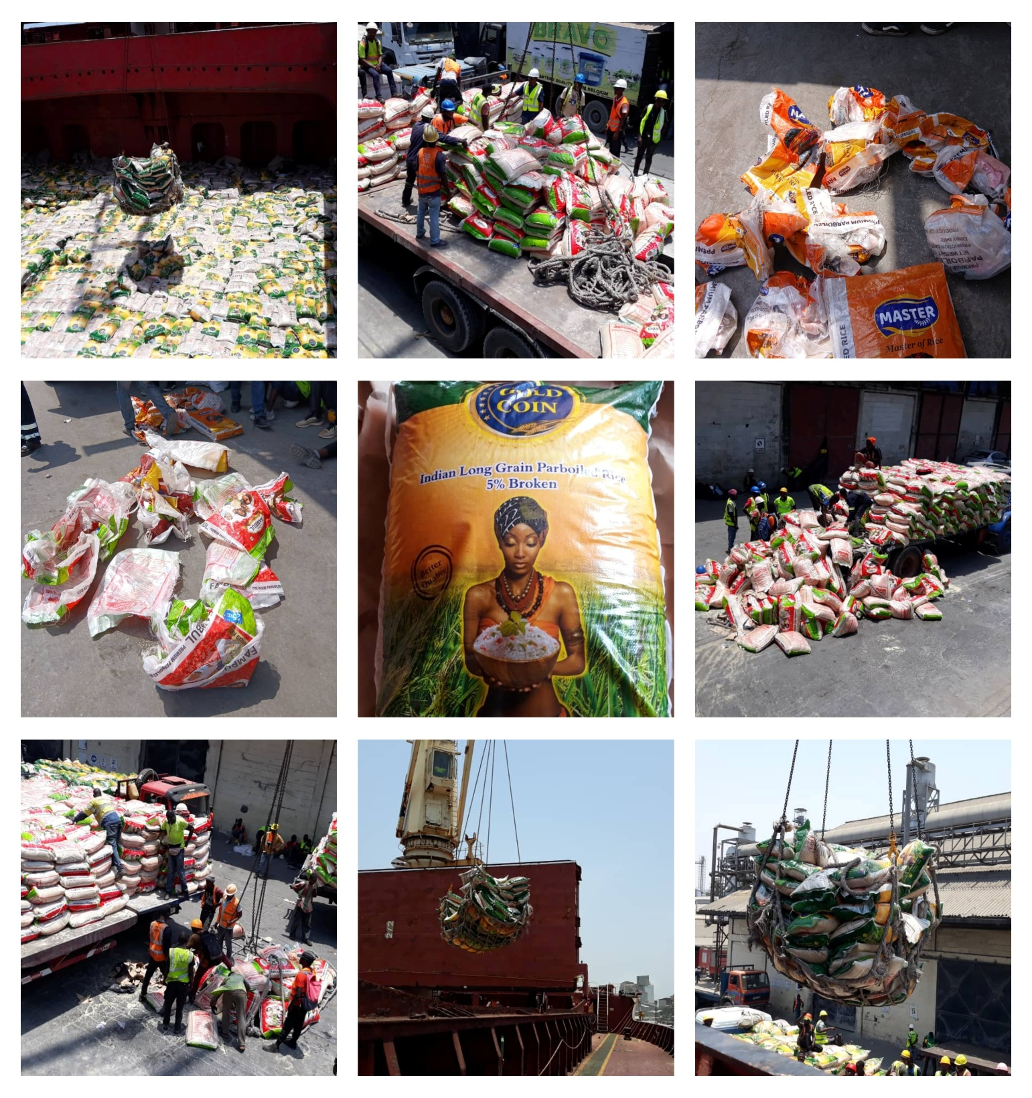

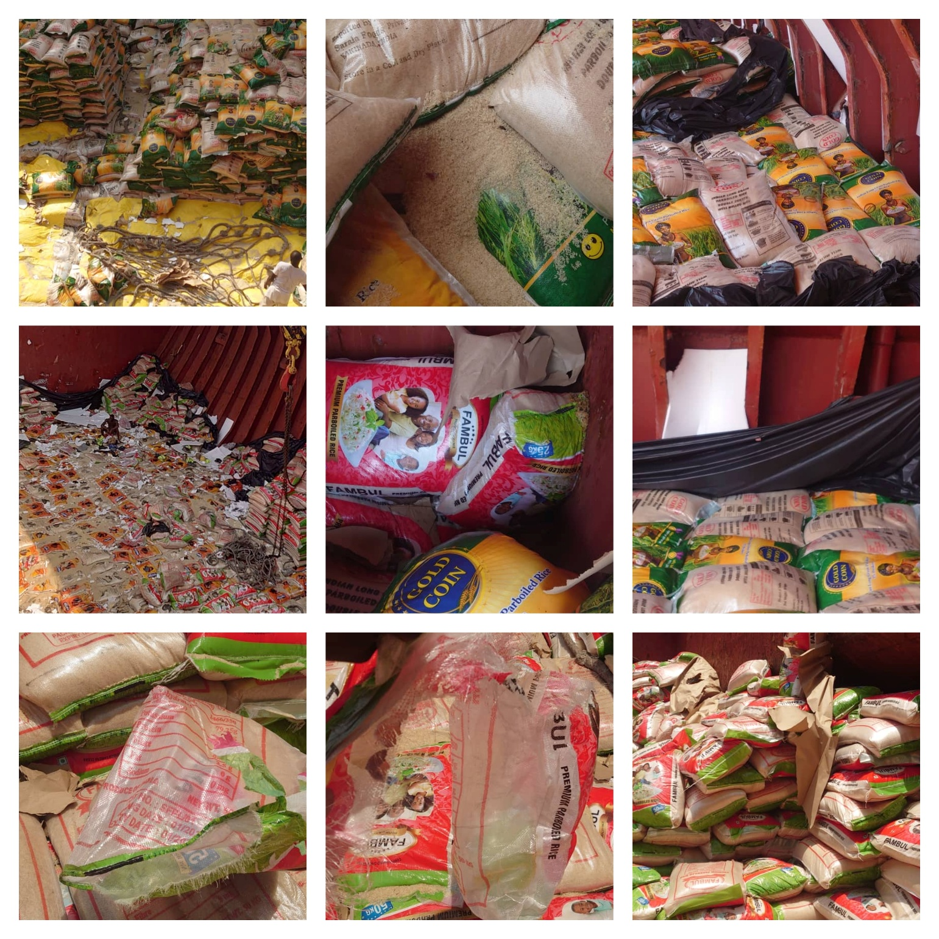

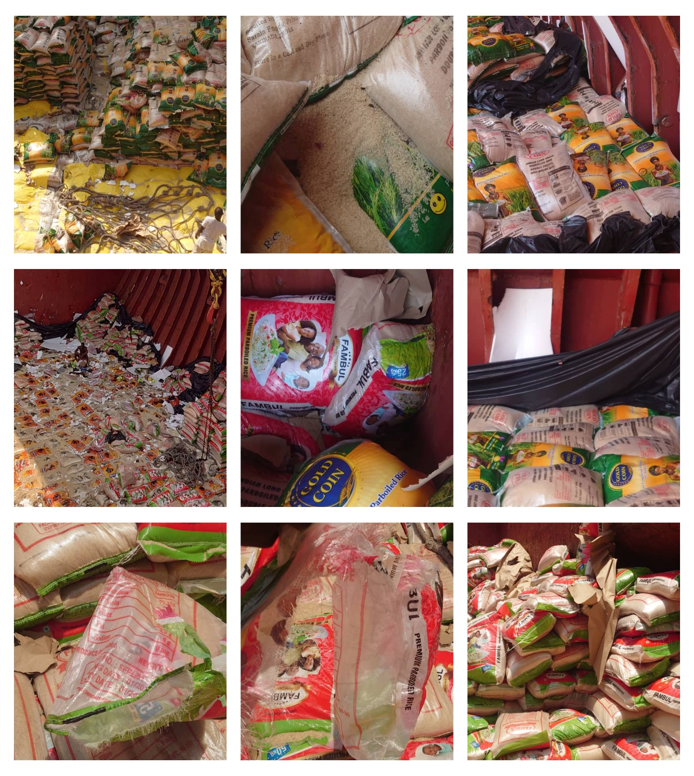

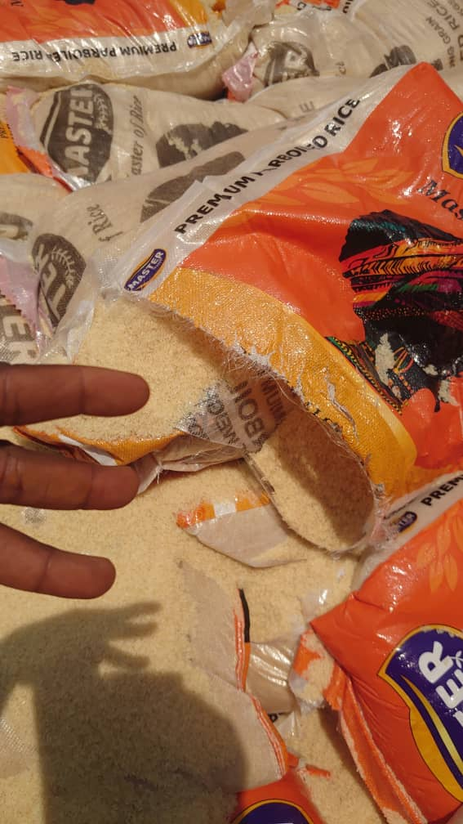

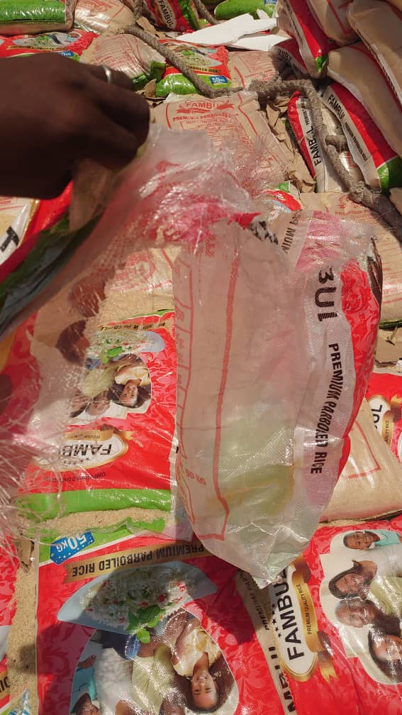

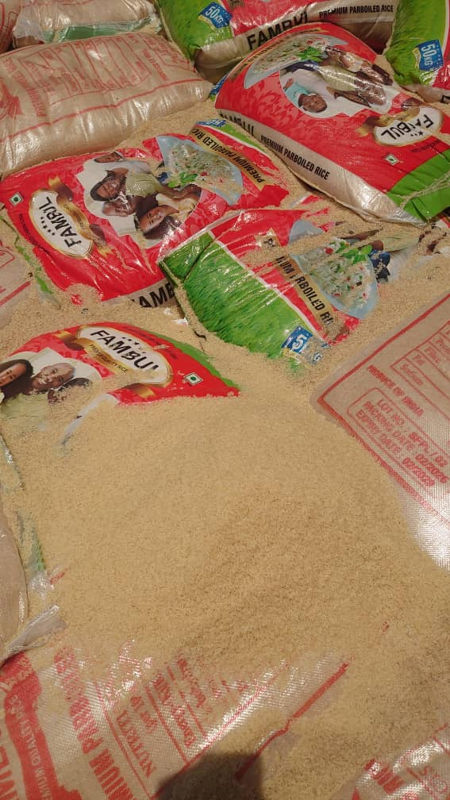

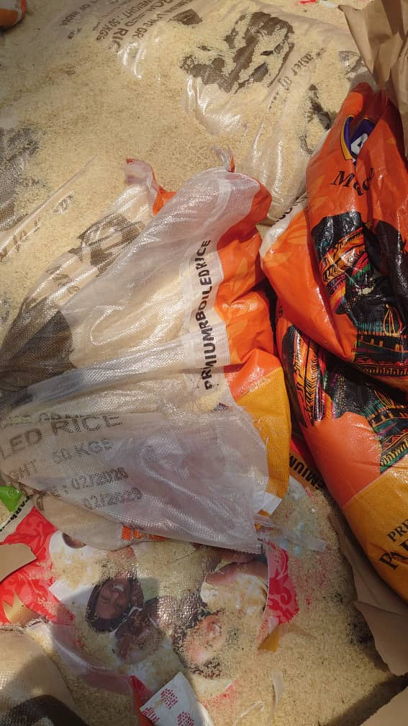
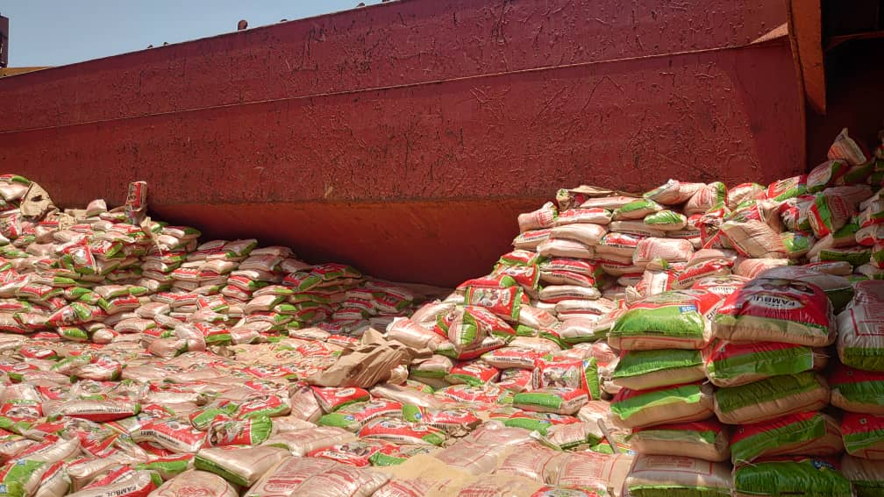
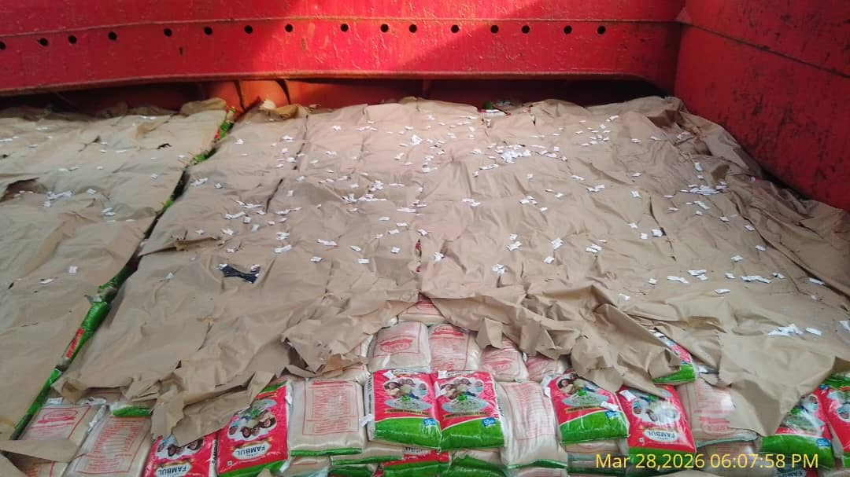

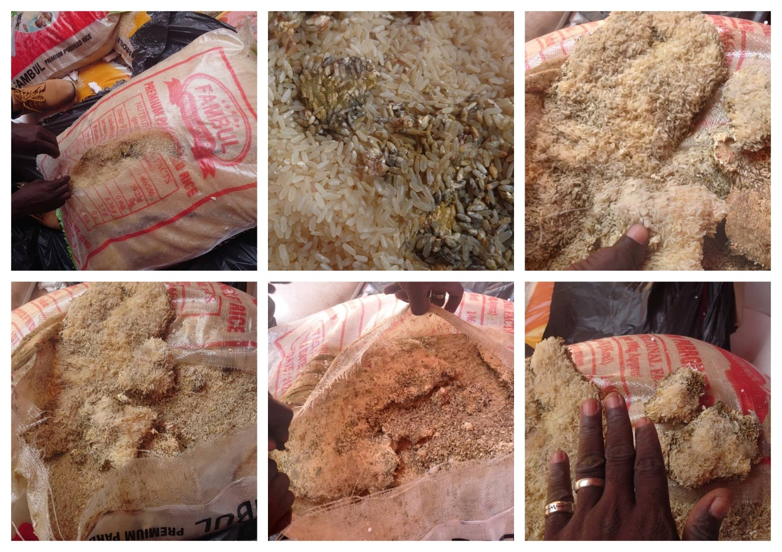
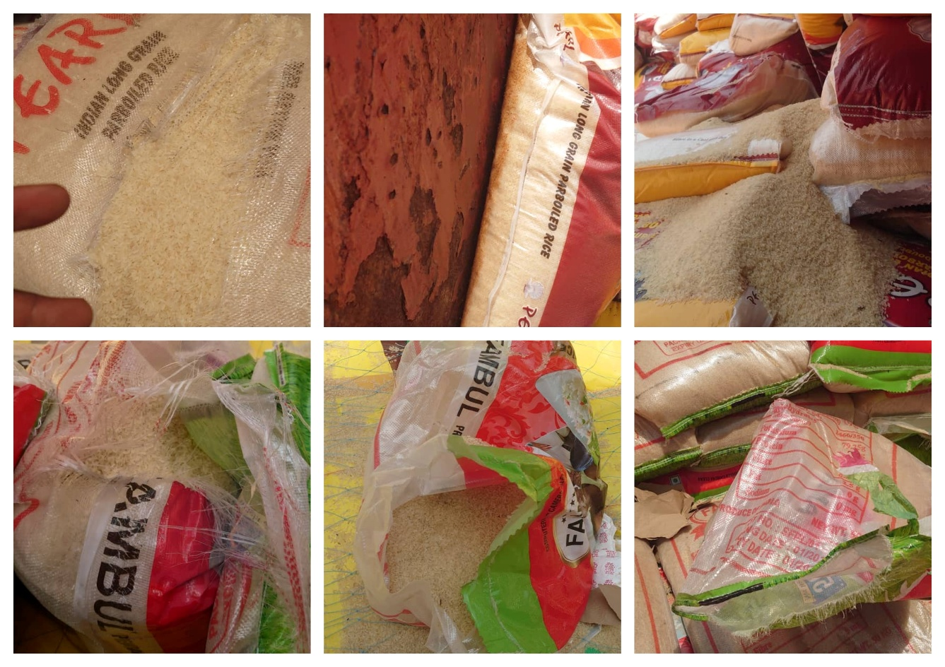

            - Joint Survey representative photographs
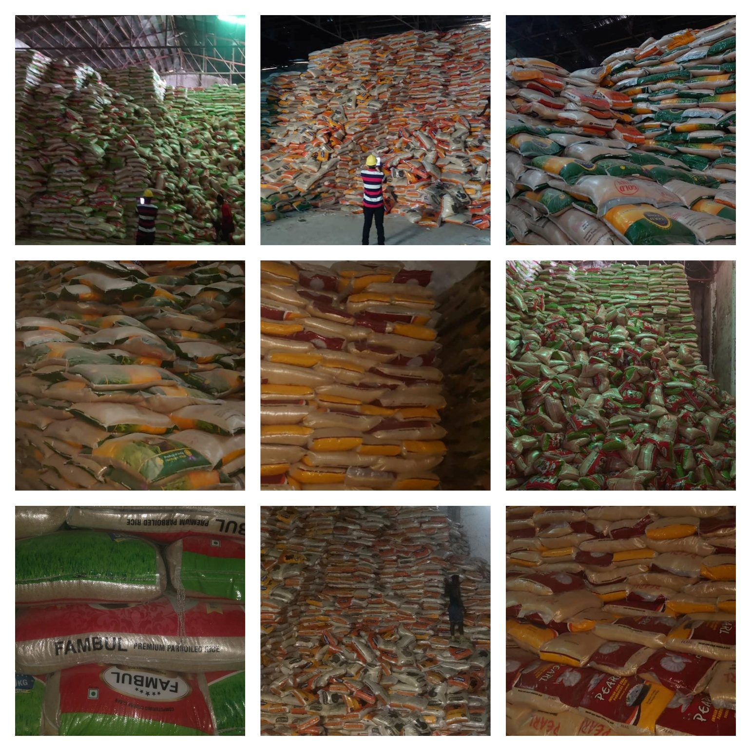

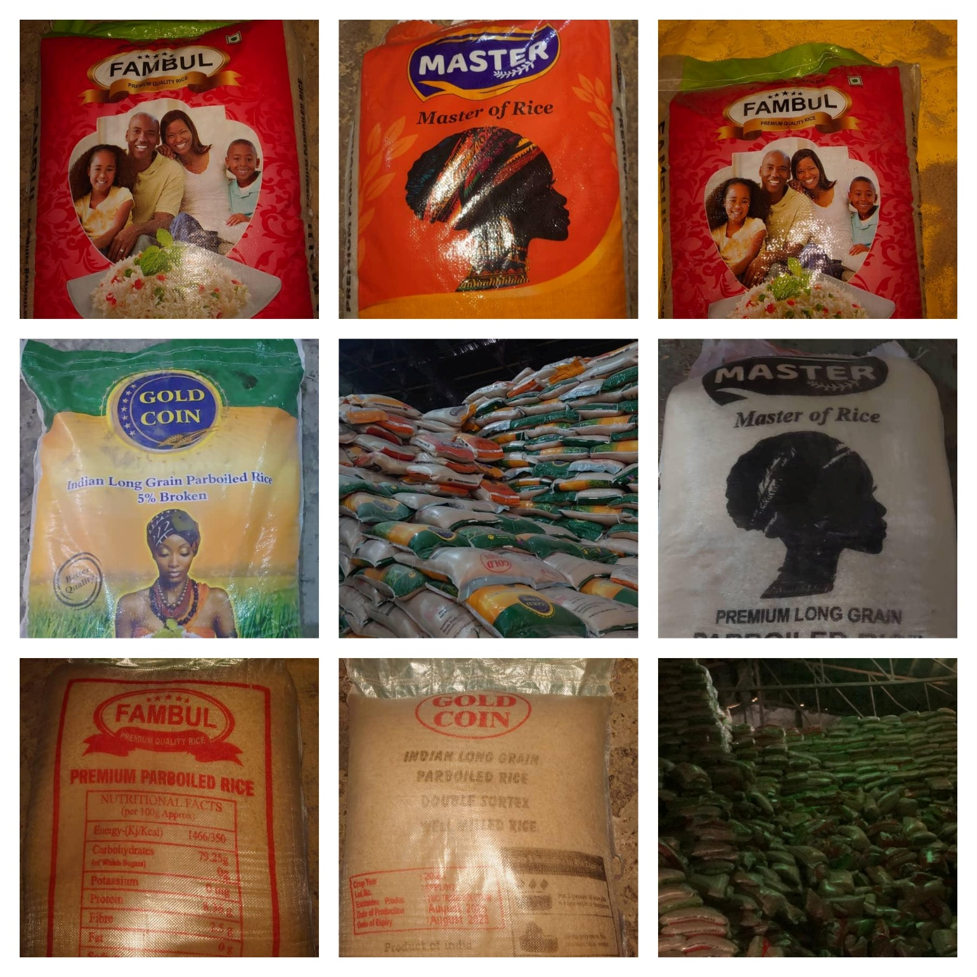

About ULA
United Loss Adjusters and Surveyors (ULA) is a leading international provider of Adjusters, Surveyors, Solicitors and Consultants, offering unrivalled technical and legal solutions with exclusive access to the London Market's leading specialists.
Established in 2002, ULA boasts strategic headquarters in both the Middle East and the United Kingdom. Today, it stands as the key partner of a premier legal firm ‘Clyde & Co.’ operating across 60+ countries and serves as the correspondent for numerous global technical service providers present in over 140 countries. Its clientele includes esteemed entities such as insurers, reinsurers, brokers, P&I clubs, ship owners, shipyards, H&M insurers, agencies, and various other stakeholders.
Lines of business:
- Insurance & Re-insurance
- Claims solutions and loss adjusting across all major lines: aviation, cargo, marine, property, fine arts, and special risks claims
- Cargo & Containers
- Marine & Offshore
- Global Claim Recoveries & Legal Support
Our team:
Our team comprises seasoned professionals proficient in Marine, Insurance, Finance, Engineering, and Law, renowned for their integrity and credibility. Backed by a dynamic, strategically located workforce, we swiftly address your queries with promptness and precision whenever and wherever our services are required. ULA maintains unwavering independence, ensuring unbiased perspectives uninfluenced by stakeholders, thereby earning your trust unequivocally.
ULA’s team members are recognised:
- Chartered Engineers
- Consultants
- Inspectors & Auditors
- Insurance & Re-Insurance Underwriters
- Loss & Average Adjusters
- Master Mariners & Chief Engineers
- Naval Architects, Marine & Offshore Engineers
- Solicitors
- Sworn Surveyors
ULA’s team members are also recognised members of the following international institutions:
- The Association of Average Adjusters (AAA)
- The Bar Council of England and Wales
- The Chartered Insurance Institute (CII)
- The Chartered Institute of Loss Adjusters (CILA)
- The European Federation of Loss Adjusting Experts (FUEDI)
- The Institute of Fire Engineers (IFE)
- The Institute of Marine Engineering, Science and Technology (IMarEST)
- The UK Engineering Council
- The Royal Institute of Naval Architects (RINA)
- The International Institute of Marine Surveying (IIMS)
- The Royal Institute of Chartered Surveyors (RICS)

Contact person
Annie Abdel Massih
Claims Director
United Kingdom: 71-75 Shelton Street, Covent Garden | London, England - WC2H 9JQ
Middle East: Mina Tower, Ain Waraka Street | Beirut, Lebanon - WG2G+5CX

Registered name United Loss Adjusters and Surveyors Ltd.

24/7 Contacts & Claim Support – T: +44 (0) 20 3287 3326 | M/WhatsApp: +44 (0) 7 375 110 573
Office E: claims@unitedlossadjusters.com
W: https://www.unitedlossadjusters.com/



